Triangular Prismoid

Definition
# Source: AI Source: Provided by: [Data Path: Persons Table -> ID Column: 1, Name_En Column: Motasem Essam] -> From: [ChatGPT] on [7/25/2026]
A Triangular Prismoid is a three-dimensional polyhedron belonging to the Prismoid family, characterized by two triangular bases lying in parallel planes and connected by three quadrilateral lateral faces.
The two triangular bases have the same number of sides but do not necessarily have the same size, shape, or orientation. The lateral faces are trapezoids or parallelograms.
It has 5 faces, 9 edges, and 6 vertices.

Geometric Structure
# Source: AI Source: Provided by: [Data Path: Persons Table -> ID Column: 1, Name_En Column: Motasem Essam] -> From: [ChatGPT] on [7/25/2026]
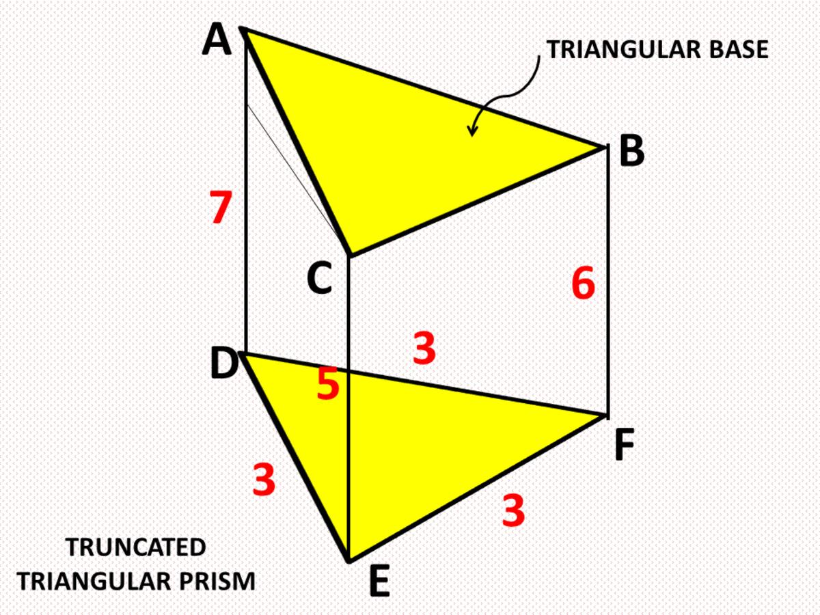
The solid consists of the following elements:
- Lower Triangular Base: A triangle forming the bottom of the solid.
- Upper Triangular Base: A triangle parallel to the lower base.
- Lateral Faces: Three quadrilateral faces connecting corresponding base edges.
- Lateral Edges: Three edges connecting the corresponding vertices of the two triangular bases.
- Altitude (Height): The perpendicular distance between the two base planes.
- Midsection: A triangular cross-section parallel to both bases, halfway between them.

Face Composition
# Source: AI Source: Provided by: [Data Path: Persons Table -> ID Column: 1, Name_En Column: Motasem Essam] -> From: [ChatGPT] on [7/25/2026]
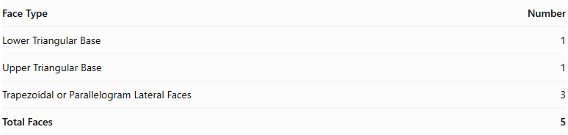
Face Type | Number
Lower Triangular Base | 1
Upper Triangular Base | 1
Trapezoidal or Parallelogram Lateral Faces | 3
Total Faces | 5
The three lateral faces may be trapezoids or parallelograms, depending on the relative positions and orientations of the bases.

Mathematical Properties
# Source: AI Source: Provided by: [Data Path: Persons Table -> ID Column: 1, Name_En Column: Motasem Essam] -> From: [ChatGPT] on [7/25/2026]
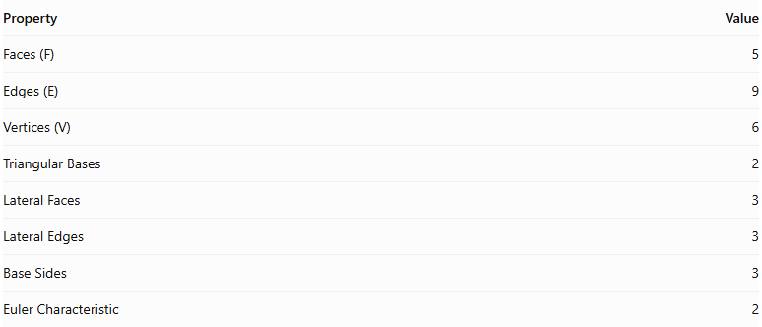
Property | Value
Faces (F) | 5
Edges (E) | 9
Vertices (V) | 6
Triangular Bases | 2
Lateral Faces | 3
Lateral Edges | 3
Base Sides | 3
Euler Characteristic | 2
Euler characteristic:
$$V-E+F=6-9+5=2$$
Volume Formula:
$$\boxed{V=\frac{h}{6}(A_{1}+4A_{m}+A_{2})}$$
Where:
- $V$ = Volume.
- $h$ = Perpendicular height.
- $A_{1}$ = Area of the lower triangular base.
- $A_{2}$ = Area of the upper triangular base.
- $A_{m}$ = Area of the triangular midsection.

Geometric Characteristics
# Source: AI Source: Provided by: [Data Path: Persons Table -> ID Column: 1, Name_En Column: Motasem Essam] -> From: [ChatGPT] on [7/25/2026]
- Triangular Bases: Both parallel bases have three sides and three vertices.
- Quadrilateral Lateral Faces: The solid has three trapezoidal or parallelogram lateral faces.
- Variable Base Dimensions: The upper and lower triangles may have different side lengths and areas.
- Inclined Lateral Edges: The connecting edges may be inclined relative to the base planes.
- Convex Structure: In its conventional form, the solid has a convex closed surface.
- Variable Geometry: Its overall appearance depends on the dimensions, shapes, and relative positioning of its two triangular bases.
Constructing a Triangular Prismoid

Constructing a Triangular Prismoid

Geometric Instruments Used
# Source: AI Source: Provided by: [Data Path: Persons Table -> ID Column: 1, Name_En Column: Motasem Essam] -> From: [ChatGPT] on [7/25/2026]
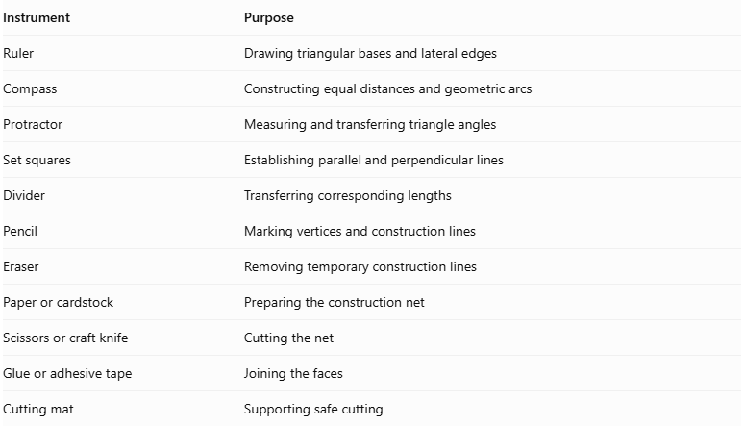
Instrument | Purpose
Ruler | Drawing triangular bases and lateral edges
Compass | Constructing equal distances and geometric arcs
Protractor | Measuring and transferring triangle angles
Set squares | Establishing parallel and perpendicular lines
Divider | Transferring corresponding lengths
Pencil | Marking vertices and construction lines
Eraser | Removing temporary construction lines
Paper or cardstock | Preparing the construction net
Scissors or craft knife | Cutting the net
Glue or adhesive tape | Joining the faces
Cutting mat | Supporting safe cutting

Instrument-Based Construction Procedures

Method 1: Construction Using a Geometric Net
# Source: AI Source: Provided by: [Data Path: Persons Table -> ID Column: 1, Name_En Column: Motasem Essam] -> From: [ChatGPT] on [7/25/2026]
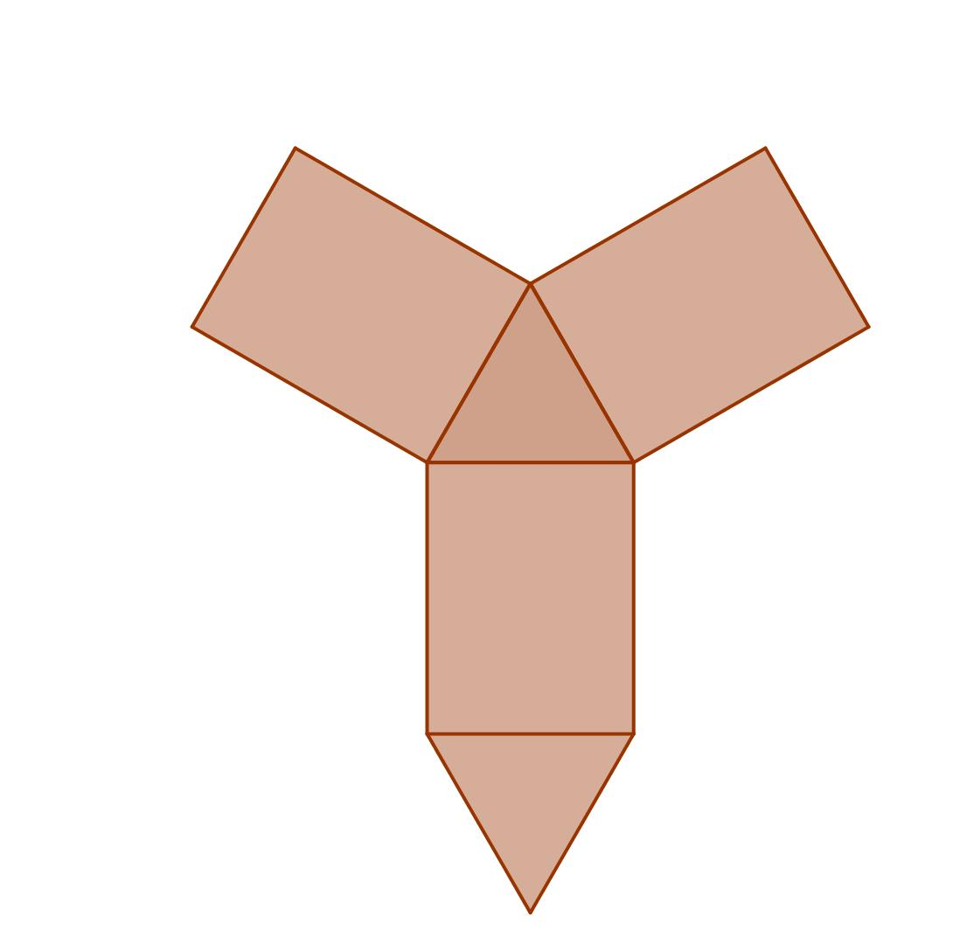
- Determine the base dimensions: Choose the side lengths and angles of the upper and lower triangular bases.
- Construct the lower triangular base: Use a ruler, compass, and protractor to draw the first triangle.
- Construct the upper triangular base: Draw the second triangle with the required dimensions and corresponding vertex arrangement.
- Determine the lateral edge lengths: Establish the lengths connecting the corresponding vertices.
- Construct the lateral faces: Draw three planar quadrilaterals using the corresponding base edges and lateral edges.
- Arrange the net: Position the three quadrilaterals in sequence, with the two triangular bases attached at their appropriate edges.
- Add joining tabs: Include tabs along selected external edges.
- Cut out the net: Carefully cut around its external boundary.
- Fold the lateral faces: Fold along the designated joining edges.
- Attach the triangular bases: Join the upper and lower triangles to the lateral structure.
- Complete the solid: Check that all nine edges and five faces meet correctly.

Method 2: Construction Using Two Parallel Triangular Bases
# Source: AI Source: Provided by: [Data Path: Persons Table -> ID Column: 1, Name_En Column: Motasem Essam] -> From: [ChatGPT] on [7/25/2026]
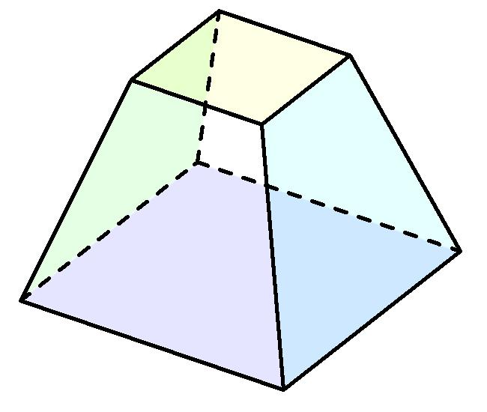
- Draw the lower triangle: Construct the first triangular base and label its vertices $A$, $B$, and $C$.
- Establish the height: Draw a perpendicular reference line representing the distance between the base planes.
- Construct the upper base plane: Use set squares and a ruler to establish a plane parallel to the lower base plane.
- Draw the upper triangle: Construct the second triangular base and label its vertices $A'$, $B'$, and $C'$.
- Determine vertex correspondence: Match $A$ with $A'$, $B$ with $B'$, and $C$ with $C'$.
- Draw the lateral edges: Connect the corresponding vertices:
- $AA'$
- $BB'$
- $CC'$
- Construct the lateral faces: Connect the corresponding base edges to form three quadrilaterals:
- $ABB'A'$
- $BCC'B'$
- $CAA'C'$
- Check planarity: Verify that each lateral quadrilateral lies in a single plane.
- Complete the representation: Darken the visible edges and use dashed lines for hidden edges.
Important: The upper triangle cannot be positioned arbitrarily. Its vertices must be arranged so that all three lateral quadrilaterals are planar.

Method 3: Construction Through Parallel Cross-Sections
# Source: AI Source: Provided by: [Data Path: Persons Table -> ID Column: 1, Name_En Column: Motasem Essam] -> From: [ChatGPT] on [7/25/2026]
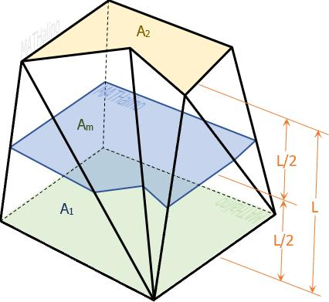
- Construct the lower base: Draw the first triangular polygon.
- Construct the upper base: Draw the second triangular polygon in a parallel plane.
- Connect corresponding vertices: Establish the three lateral edges.
- Construct the lateral faces: Form the three planar quadrilaterals.
- Locate the midpoint of each lateral edge: Use a divider to identify the halfway point on $AA'$, $BB'$, and $CC'$.
- Construct the midsection: Connect the three midpoint locations to form a triangle parallel to both bases.
- Determine the cross-sectional areas: Calculate the lower-base, upper-base, and midsection areas.
- Complete the geometric representation: Label the three areas and the perpendicular height.
This method is useful for understanding and applying the prismoidal volume formula.

Related Geometric Solids
# Source: AI Source: Provided by: [Data Path: Persons Table -> ID Column: 1, Name_En Column: Motasem Essam] -> From: [ChatGPT] on [7/25/2026]
- Triangular Prism – A special case with congruent parallel triangular bases.
- Triangular Pyramidal Frustum – A special case with similar triangular bases.
- Triangular Prismatoid – The broader related geometric category.
- Tetrahedron – A related triangular-faced polyhedron, but not a triangular prismoid under the narrower definition.

Main Classification
# Source: AI Source: Provided by: [Data Path: Persons Table -> ID Column: 1, Name_En Column: Motasem Essam] -> From: [ChatGPT] on [7/25/2026]
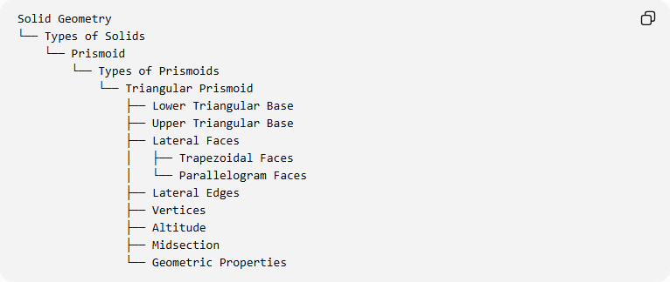
Solid Geometry
└── Types of Solids
└── Prismoid
└── Types of Prismoids
└── Triangular Prismoid
├── Lower Triangular Base
├── Upper Triangular Base
├── Lateral Faces
│ ├── Trapezoidal Faces
│ └── Parallelogram Faces
├── Lateral Edges
├── Vertices
├── Altitude
├── Midsection
└── Geometric Properties

Key Points
# Source: AI Source: Provided by: [Data Path: Persons Table -> ID Column: 1, Name_En Column: Motasem Essam] -> From: [ChatGPT] on [7/25/2026]
- A Triangular Prismoid has two parallel triangular bases.
- It contains three quadrilateral lateral faces.
- It has 5 faces, 9 edges, and 6 vertices.
- Its bases may differ in size, shape, and orientation.
- Its lateral faces are trapezoids or parallelograms.
- Its volume is calculated using the prismoidal formula.

Conclusion
# Source: AI Source: Provided by: [Data Path: Persons Table -> ID Column: 1, Name_En Column: Motasem Essam] -> From: [ChatGPT] on [7/25/2026]
The Triangular Prismoid is the three-sided-base member of the Prismoid family. Its two parallel triangular bases and three quadrilateral lateral faces define its structure, while its variable base geometry allows several different solid configurations.

